**Day 4 Assignment**

**Name : Kousalya Palanisamy**

**Email : [kousiraaj45@gmail.com](mailto:kousiraaj45@gmail.com)**

**Date: 24-08-2020**

**Linux 1 Server → Public IP - 18.224.19.196**

**Linux 2 Server → Public IP - 3.129.43.4**

**LoadBalancerELB → DNS Name -** LoadBalancerELB-2102229436.us-east-2.elb.amazonaws.com

**Linux 1**

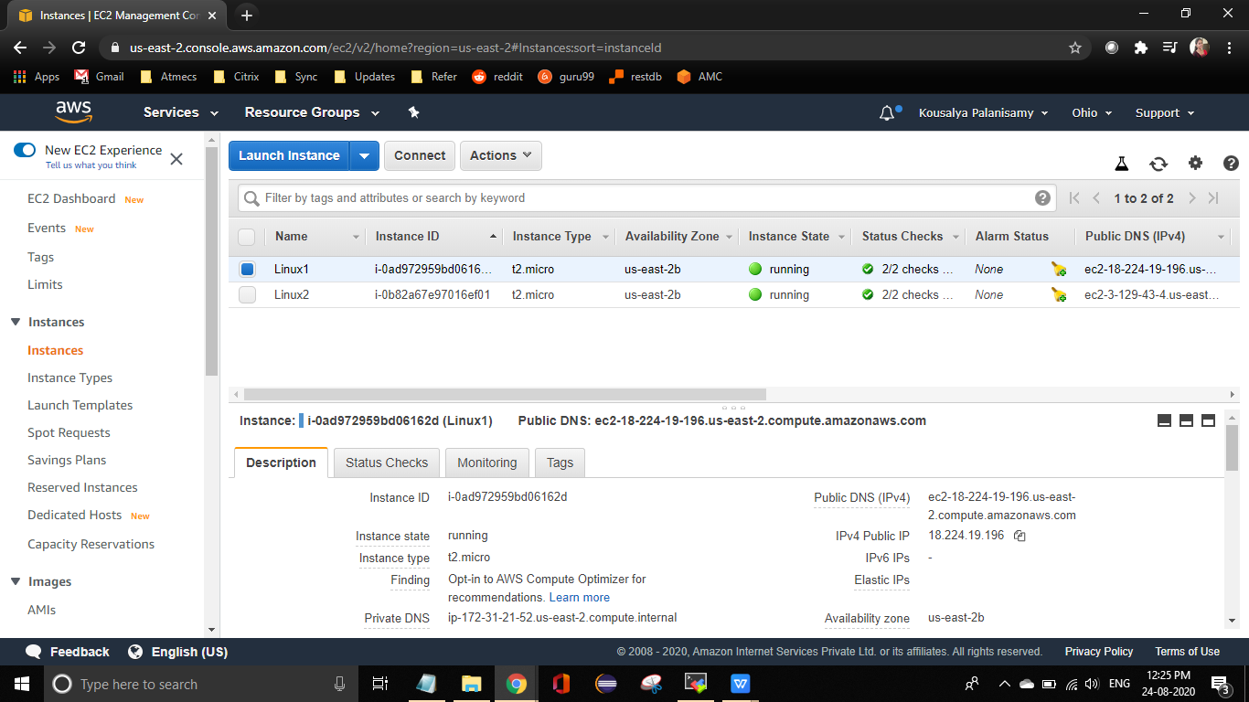

**Linux 2**

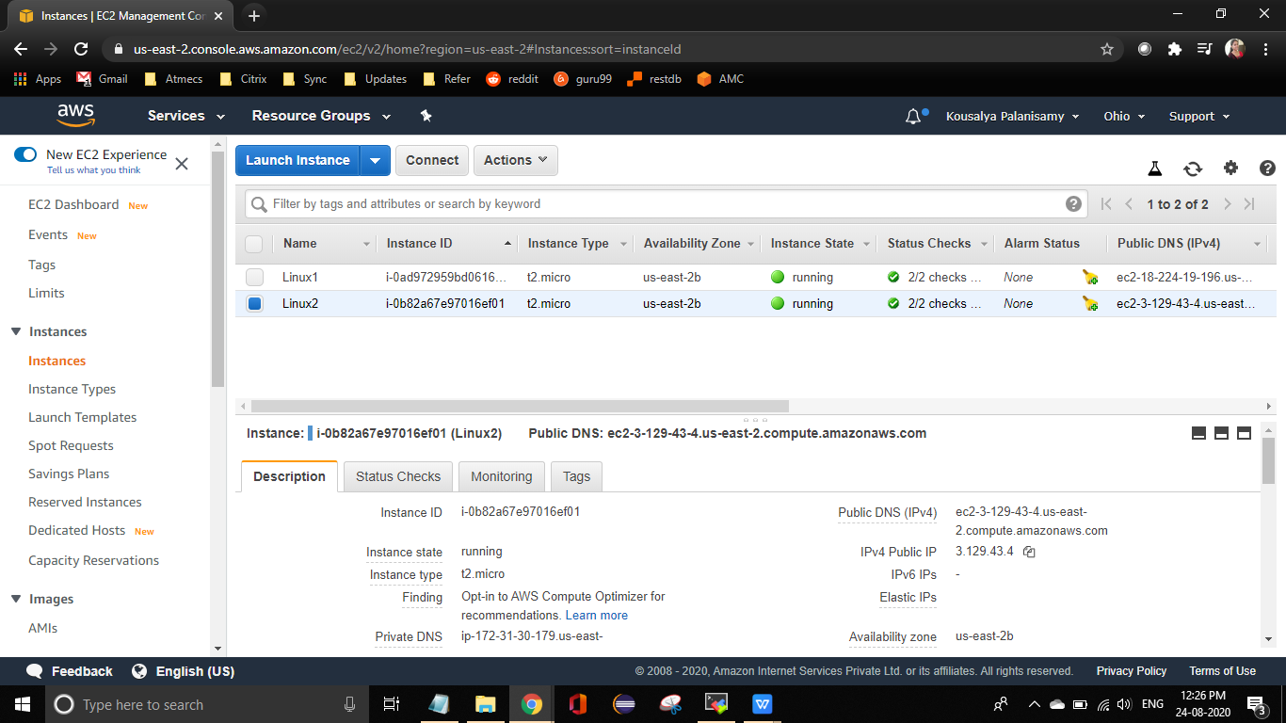

**Load Balancer**

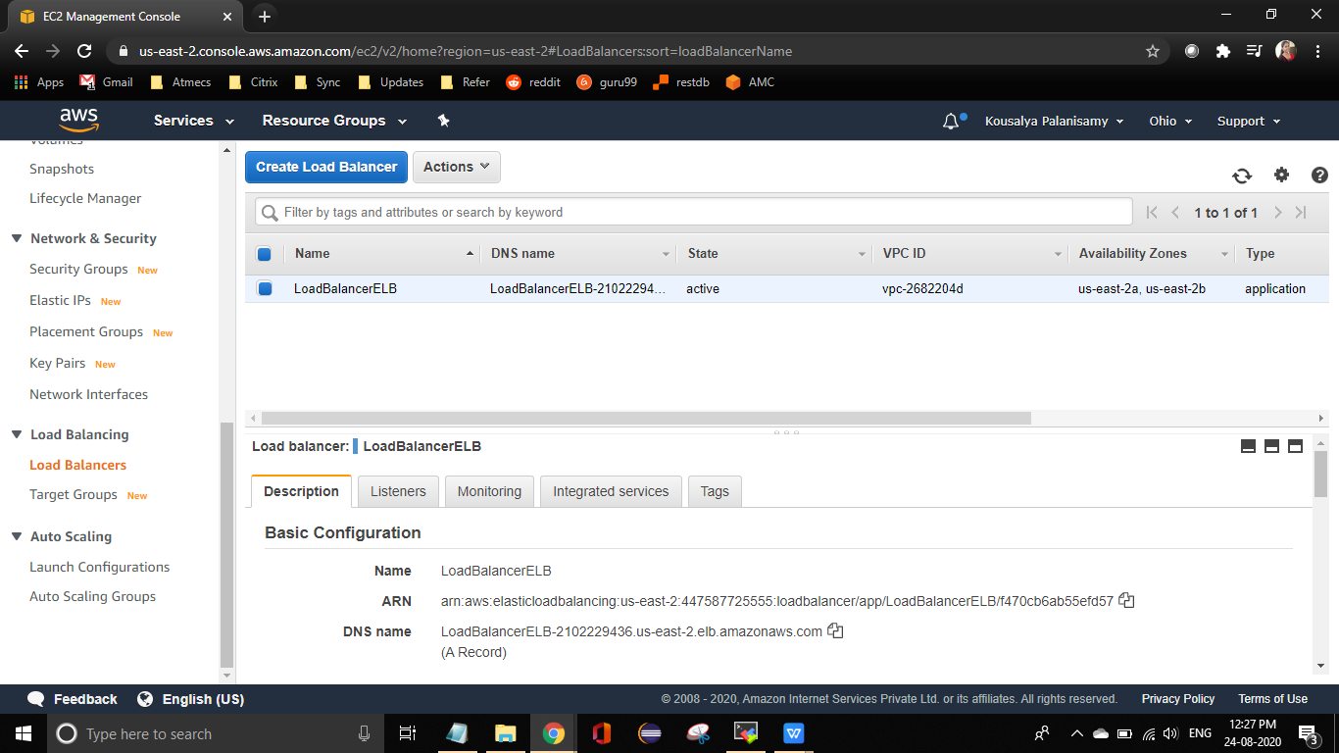

**18.224.19.196**

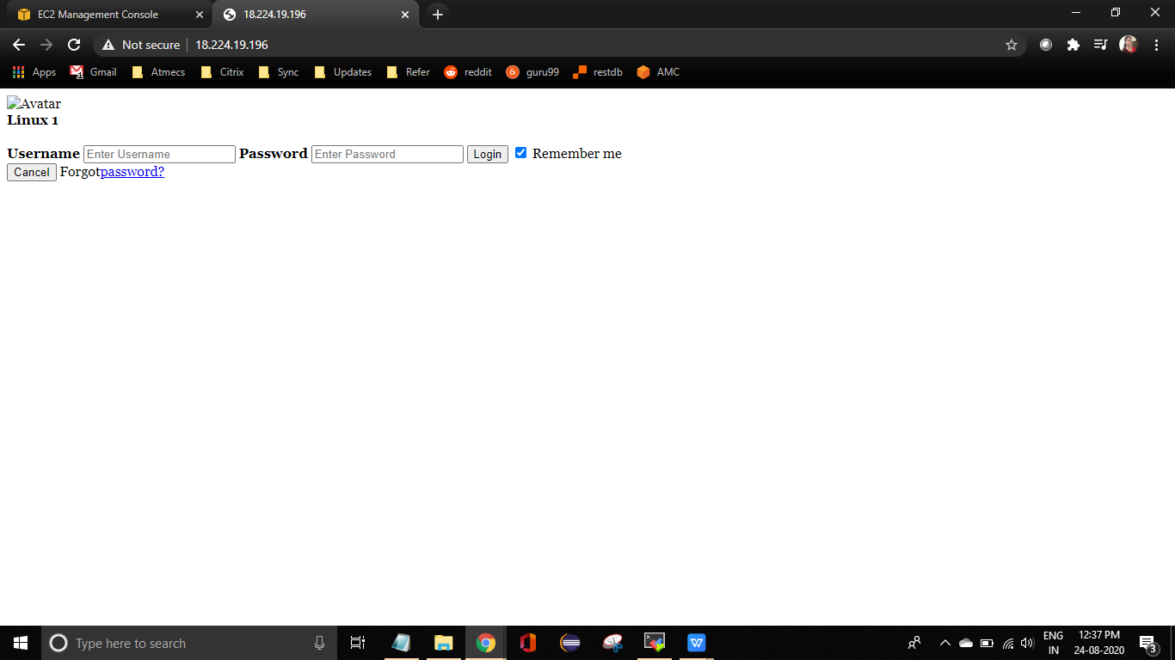

**3.129.43.4**

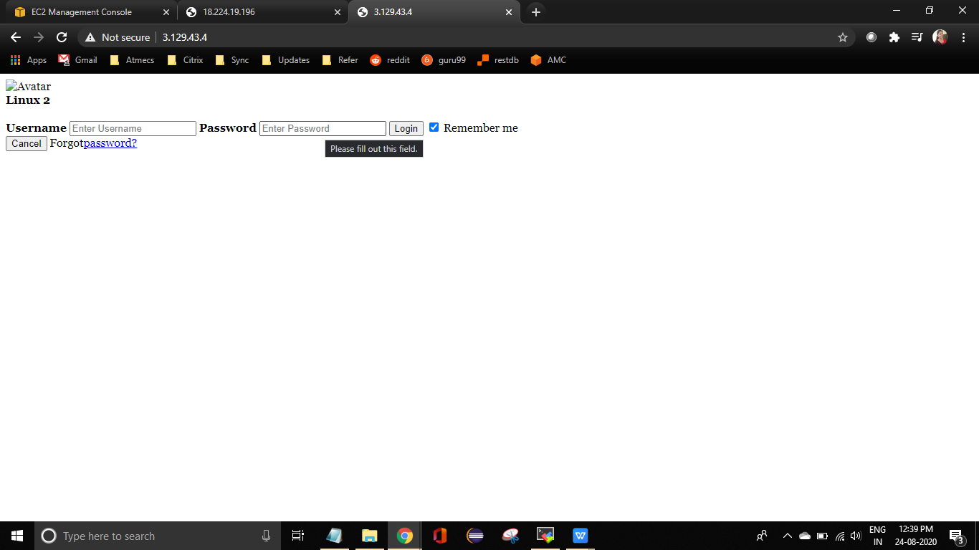

**LoadBalancerELB-2102229436.us-east-2.elb.amazonaws.com**

